BlockFund AI: A Blockchain-Based Crowdfunding Platform with AI-Powered Campaign Evaluation

1. Introduction
Crowdfunding has become an effective method for raising funds for social causes, medical emergencies, education, startups, and charitable initiatives. However, traditional crowdfunding platforms often suffer from problems such as fraudulent campaigns, lack of transparency, delayed verification, and reduced donor trust.
To overcome these challenges, this project proposes BlockFund AI, a secure crowdfunding platform that combines Blockchain Technology and Artificial Intelligence. Blockchain ensures transparency, immutability, and secure financial transactions, while AI evaluates campaign credibility and predicts campaign success before publication.
The platform enables campaign creators to create fundraising campaigns, donors to contribute securely using cryptocurrency wallets, and administrators to review campaigns using AI-generated trust scores before approving them.

2. Problem Statement
Existing crowdfunding platforms face several challenges:
- Fake or fraudulent fundraising campaigns.
- Lack of transparency in fund utilization.
- Manual campaign verification.
- Low donor confidence.
- Difficulty in evaluating campaign authenticity.
- Centralized transaction management.
These limitations reduce trust among donors and affect the success of genuine fundraising campaigns.

3. Proposed Solution
The proposed system integrates Artificial Intelligence with Blockchain Technology to create a secure and transparent crowdfunding platform.
The AI module analyzes campaign information such as campaign goal, description, category, and duration to generate a Trust Score, Success Probability, and Risk Level.
Blockchain technology securely records donation transactions using Ethereum smart contracts, ensuring complete transparency and preventing transaction manipulation.

4. Objectives
The primary objectives of the proposed system are:
- Develop a secure crowdfunding platform.
- Integrate Artificial Intelligence for campaign evaluation.
- Generate AI-based Trust Scores for campaigns.
- Record donations securely using blockchain.
- Improve donor confidence through transparency.
- Provide role-based authentication for Users and Administrators.
- Enable MetaMask wallet integration for cryptocurrency donations.
- Provide administrators with AI-assisted campaign approval.

5. Scope of the Project
The proposed platform can be used for:
- Medical fundraising
- Educational support
- Startup funding
- Disaster relief
- Charity campaigns
- NGO fundraising
- Community welfare projects
Future enhancements include mobile applications, multi-chain blockchain support, multilingual interfaces, and advanced fraud detection using deep learning.

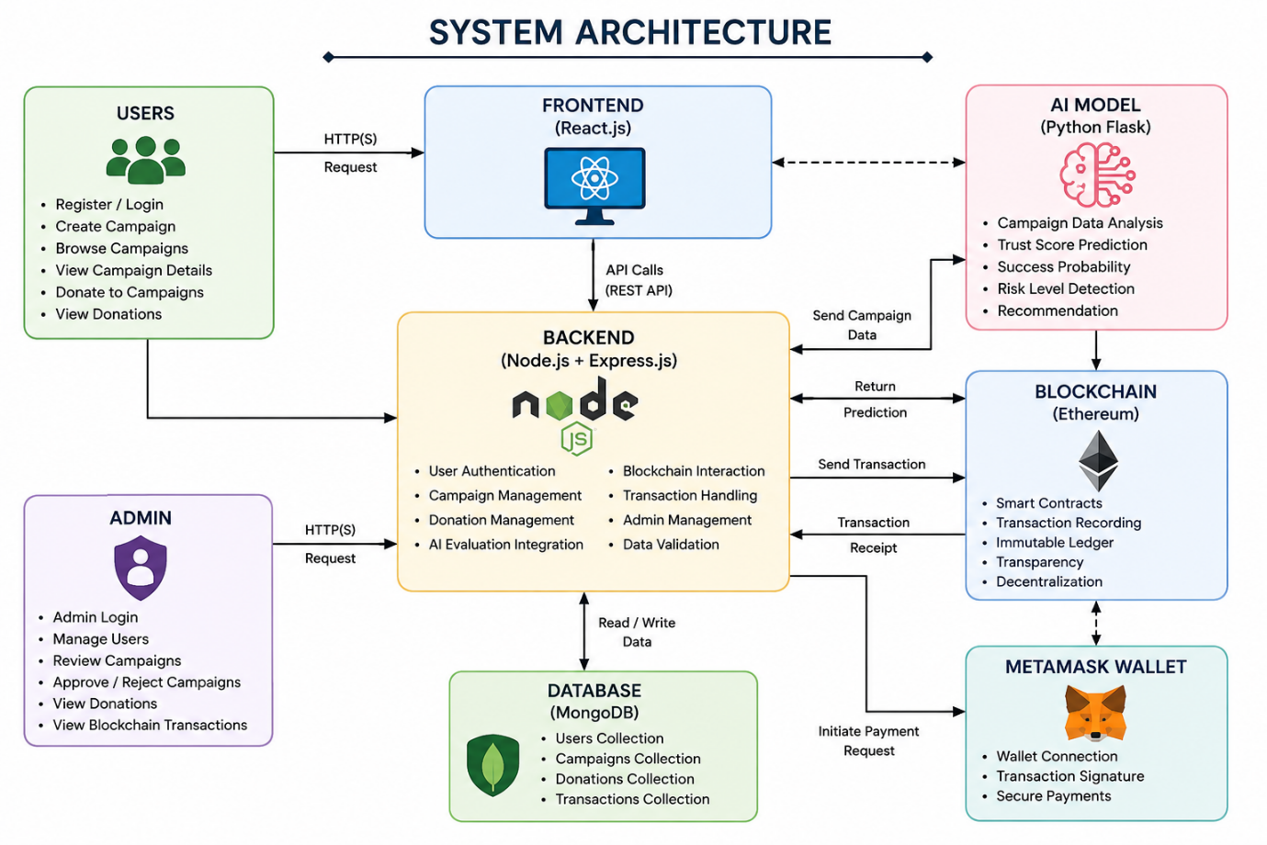

7. Modules

Module 1: User Authentication
- User Registration
- User Login
- Admin Login
- Role-Based Access
- JWT Authentication (Backend)

Module 2: Campaign Management
- Create Campaign
- Upload Campaign Image
- Campaign Listing
- Campaign Details
- AI Evaluation
- Campaign Status

Module 3: AI Campaign Evaluation
The AI model evaluates campaigns using:
- Campaign Goal
- Description
- Category
- Duration
Output:
- AI Trust Score
- Success Probability
- Risk Level
- Recommendation

Module 4: Blockchain Integration
- Ethereum Smart Contracts
- MetaMask Wallet Connection
- Donation Transactions
- Immutable Transaction Records

Module 5: Donation Module
- Secure Donations
- Wallet Authentication
- Transaction History
- Blockchain Verification

Module 6: Admin Module
Administrator Features:
- Dashboard
- View Users
- Approve Campaigns
- Reject Campaigns
- AI Risk Review
- Blockchain Transaction Monitoring
- Donation Monitoring

8. Technologies Used
Component | Technology
Frontend | React.js
Backend | Node.js, Express.js
Database | MongoDB
AI Model | Python, Flask, Scikit-learn
Blockchain | Ethereum
Smart Contract | Solidity
Wallet | MetaMask
Styling | CSS3
API Testing | Postman

9. Hardware Requirements
- Intel Core i5 Processor or above
- 8 GB RAM (Minimum)
- 20 GB Free Storage
- Internet Connection

10. Software Requirements
- Windows 10/11
- Visual Studio Code
- Node.js
- MongoDB
- Python 3.x
- MetaMask Browser Extension
- Ganache (Testing)
- Remix IDE
- Postman
- Git

11. Expected Outcomes
The proposed system is expected to:
- Increase donor trust.
- Improve campaign transparency.
- Reduce fraudulent campaigns.
- Automate campaign verification using AI.
- Secure donation records using blockchain.
- Provide a scalable crowdfunding solution.

12. Advantages
- AI-powered campaign evaluation.
- Transparent blockchain transactions.
- Secure cryptocurrency donations.
- Decentralized transaction records.
- Role-based user management.
- Professional dashboard for users and administrators.
- Improved fundraising efficiency.

13. Future Enhancements
- Mobile Application
- Multi-Cryptocurrency Support
- NFT-based Donation Certificates
- Real-time Fraud Detection
- Machine Learning Model Optimization
- Cloud Deployment (AWS/Azure)
- AI Chatbot Support
- QR Code Payments

14. Conclusion
The proposed BlockFund AI platform combines Artificial Intelligence and Blockchain Technology to provide a secure, transparent, and intelligent crowdfunding solution. AI enhances campaign credibility through automated trust evaluation, while blockchain ensures secure and immutable donation records. The system offers an innovative approach to digital fundraising by increasing transparency, minimizing fraud, and improving donor confidence. This project demonstrates the practical integration of modern technologies to address real-world challenges in online crowdfunding.

